BODY DETECTION
ABSTRACT
This System design a mobile rescue robotic Vehicle system based on Arduino to help the people on time which are trapped in natural calamity like disaster, earthquake, floods etc. It gives timely & accurately reflect dynamic situation of human in disaster region like in the underground regions to control room, so that rescue team of Experts & doctors can be sending to the victim’s location for primary treatment and can be sent to the safe place or hospital. The entire process takes place within a few seconds as the system is controlled by a Arduino unit. PIR sensors are passive infrared sensors which detects movement of people with the help of changes in the infrared (heat) levels emitted by surrounding objects. The human body emits thermal radiation at a wavelength of about 10 microns. It is received and manipulated by the PIR sensor to detect human beings. It operates at 5V DC. The motion of the human being can be detected by checking for a sudden change in the surrounding IR patterns. Obstacle sensor detects the obstacle and sends the analog signals to the Arduino. Arduino is programmed to guide the robot automatically depending on the obstacle detected and to send the human being information to remote control place through the Bluetooth Technology. The Data is received in the Base Station (Control Center). Analyzing the data the Rescue team can take necessary steps to rescue the trapped human Beings.

BLOCK DIAGRAM

Arduino UNO Micro controller
Power Supply
Temperature Sensor (DHT11)
PIR Sensor
Ultra Sonic Sensor
LCD Display
IOT Module
Buzzer
2 Axis mechanism

WORKING PRINCIPAL

In this proto type. The inputs to ARDUINO are PIR sensor, Ultrasonic sensor, Temperature sensor and power supply.
The outputs are LCD, Buzzer and IOT Module which enabled with L293D motor driver module, to which a DC motor is connected. A DC motor is used to move the robot in left, right, forward and backward directions. L293D motor drive module controls the DC motor to move in the direction.
The direction of the movement is decided as according to program code written. Human can be detected using a PIR sensor. Human being produces 9 to 10 microns of heat which is detected using this sensor. A PIR sensor’s angle of detection is restricted to 180° i.e. except the area below the robot it can sense in all the other directions. The distance up to which PIR sensor can detect is restricted within 10ft.
When we will start the Robot, it will move in forward direction, Once the human presence is detected by PIR sensor it stops for some time and triggers the LCD and Buzzer to ON to indicate that there is a presence of a human. The Ultrasonic sensor detects the obstacles other than human beings and get deflected from its current path according to program.

HARDWARE REQUIRED
- Power Supply
- Temperature Sensor
- PIR Sensor
- Ultrasonic Sensor
- Arduino Uno Microcontroller
- LCD Display
- IOT Module
- 2 Axis Mechanism

SOFTWARE REQUIRED

- Arduino IDE Complier
- Proteus Testing Tool
- Embedded C

HARDWARE DESCRIPTION

POWER SUPPLY

The ac voltage, typically 220V rms, is connected to a transformer, which steps that ac voltage down to the level of the desired dc output. A diode rectifier then provides a full-wave rectified voltage that is initially filtered by a simple capacitor filter to produce a dc voltage. This resulting dc voltage usually has some ripple or ac voltage variation.

A regulator circuit removes the ripples and also remains the same dc value even if the input dc voltage varies, or the load connected to the output dc voltage changes. This voltage regulation is usually obtained using one of the popular voltage regulator IC units.
TRANSFORMER
RECTIFIER
FILTER
IC REGULATOR
LOAD

Fig. Block Diagram of Power supply
Working principle
Transformer
The potential transformer will step down the power supply voltage (0-230V) to (0-6V) level. Then the secondary of the potential transformer will be connected to the precision rectifier, which is constructed with the help of op–amp. The advantages of using precision rectifier are it will give peak voltage output as DC, rest of the circuits will give only RMS output.

Bridge rectifier
When four diodes are connected as shown in figure, the circuit is called as bridge rectifier. The input to the circuit is applied to the diagonally opposite corners of the network, and the output is taken from the remaining two corners.

Let us assume that the transformer is working properly and there is a positive potential, at point A and a negative potential at point B. the positive potential at point A will forward bias D3 and reverse bias D4.

The negative potential at point B will forward bias D1 and reverse D2. At this time D3 and D1 are forward biased and will allow current flow to pass through them; D4 and D2 are reverse biased and will block current flow.

The path for current flow is from point B through D1, up through RL, through D3, through the secondary of the transformer back to point B. this path is indicated by the solid arrows. Waveforms (1) and (2) can be observed across D1 and D3.

One-half cycle later the polarity across the secondary of the transformer reverse, forward biasing D2 and D4 and reverse biasing D1 and D3. Current flow will now be from point A through D4, up through RL, through D2, through the secondary of T1, and back to point A. This path is indicated by the broken arrows. Waveforms (3) and (4) can be observed across D2 and D4. The current flow through RL is always in the same direction. In flowing through RL this current develops a voltage corresponding to that shown waveform (5). Since current flows through the load (RL) during both half cycles of the applied voltage, this bridge rectifier is a full-wave rectifier.

One advantage of a bridge rectifier over a conventional full-wave rectifier is that with a given transformer the bridge rectifier produces a voltage output that is nearly twice that of the conventional full-wave circuit.

This may be shown by assigning values to some of the components shown in views A and B. assume that the same transformer is used in both circuits. The peak voltage developed between points X and y is 1000 volts in both circuits. In the conventional full-wave circuit shown—in view A, the peak voltage from the center tap to either X or Y is 500 volts. Since only one diode can conduct at any instant, the maximum voltage that can be rectified at any instant is 500 volts.

The maximum voltage that appears across the load resistor is nearly-but never exceeds-500 v0lts, as result of the small voltage drop across the diode. In the bridge rectifier shown in view B, the maximum voltage that can be rectified is the full secondary voltage, which is 1000 volts. Therefore, the peak output voltage across the load resistor is nearly 1000 volts. With both circuits using the same transformer, the bridge rectifier circuit produces a higher output voltage than the conventional full-wave rectifier circuit.

IC voltage regulators
Voltage regulators comprise a class of widely used ICs. Regulator IC units contain the circuitry for reference source, comparator amplifier, control device, and overload protection all in a single IC. IC units provide regulation of either a fixed positive voltage, a fixed negative voltage, or an adjustably set voltage. The regulators can be selected for operation with load currents from hundreds of milli amperes to tens of amperes, corresponding to power ratings from milli watts to tens of watts.
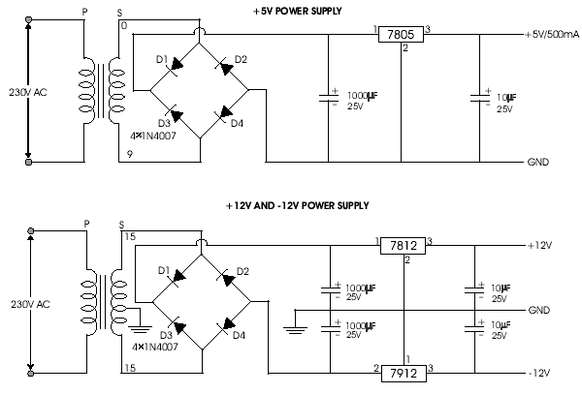Fig.Circuit Diagram of Power Supply
A fixed three-terminal voltage regulator has an unregulated dc input voltage, Vi, applied to one input terminal, a regulated dc output voltage, Vo, from a second terminal, with the third terminal connected to ground.
The series 78 regulators provide fixed positive regulated voltages from 5 to 24 volts. Similarly, the series 79 regulators provide fixed negative regulated voltages from 5 to 24 volts.

- For ICs, microcontroller, LCD --------- 12 volts
- For alarm circuit, op-amp, relay circuits ---------- 5 volts

TEMPERATURE SENSOR (DHT11)
The DHT11 humidity and temperature sensor makes it really easy to add humidity and temperature data to your DIY electronics projects. It’s perfect for remote weather stations, home environmental control systems, and farm or garden monitoring systems.
I’ll first go into a little background about humidity, then I’ll explain how the DHT11 measures humidity. After that, I’ll show you how to connect the DHT11 to an Arduino and give you some example code so you can use the DHT11 in your own projects.
WHAT IS RELATIVE TEMPERATURE/HUMIDITY
The DHT11 measures relative humidity. Relative humidity is the amount of water vapor in air vs. the saturation point of water vapor in air. At the saturation point, water vapor starts to condense and accumulate on surfaces forming dew.

The saturation point changes with air temperature. Cold air can hold less water vapor before it becomes saturated, and hot air can hold more water vapor before it becomes saturated. Relative humidity is expressed as a percentage. At 100% RH, condensation occurs, and at 0% RH, the air is completely dry.
HOW THE DHT11 MEASURES HUMIDITY AND TEMPERATURE
The DHT11 detects water vapor by measuring the electrical resistance between two electrodes. The humidity sensing component is a moisture holding substrate with electrodes applied to the surface. When water vapor is absorbed by the substrate, ions are released by the substrate which increases the conductivity between the electrodes. The change in resistance between the two electrodes is proportional to the relative humidity. Higher relative humidity decreases the resistance between the electrodes, while lower relative humidity increases the resistance between the electrodes.

The DHT11 measures temperature with a surface mounted NTC temperature sensor (thermistor) built into the unit. To learn more about how thermistors work and how to use them on the Arduino, check out our Arduino Thermistor Temperature Sensor Tutorial.
With the plastic housing removed, you can see the electrodes applied to the substrate

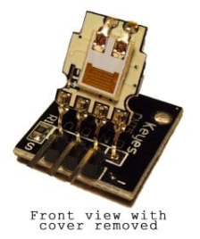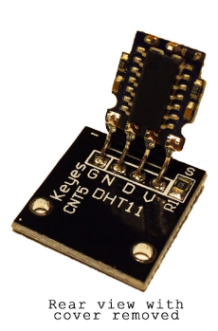
An IC mounted on the back of the unit converts the resistance measurement to relative humidity. It also stores the calibration coefficients, and controls the data signal transmission between the DHT11 and the Arduino:

The DHT11 uses just one signal wire to transmit data to the Arduino. Power comes from separate 5V and ground wires. A 10K Ohm pull-up resistor is needed between the signal line and 5V line to make sure the signal level stays high by default (see the datasheet for more info).

There are two different versions of the DHT11 you might come across. One type has four pins, and the other type has three pins and is mounted to a small PCB. The PCB mounted version is nice because it includes a surface mounted 10K Ohm pull up resistor for the signal line. Here are the pin outs for both versions:
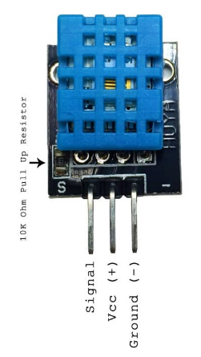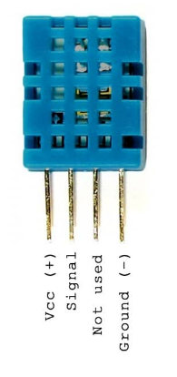

ULTRASONIC SENSOR.

Product features:

Ultrasonic ranging module HC - SR04 provides 2cm - 400cm non-contact measurement function, the ranging accuracy can reach to 3mm. The modules includes ultrasonic transmitters, receiver and control circuit. The basic principle of work:
- Using IO trigger for at least 10us high level signal,
- The Module automatically sends eight 40 kHz and detect whether there is a pulse signal back.
- IF the signal back, through high level , time of high output IO duration is the time from sending ultrasonic to returning. Test distance = (high level time×velocity of sound (340M/S) / 2,

Wire connecting direct as following:
- 5V Supply
- Trigger Pulse Input
- Echo Pulse Output
- 0V Ground
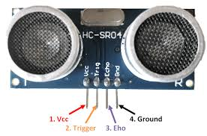

Timing diagram

The Timing diagram is shown below. You only need to supply a short 10uS pulse to the trigger input to start the ranging, and then the module will send out an 8 cycle burst of ultrasound at 40 kHz and raise its echo. The Echo is a distance object that is pulse width and the range in proportion .You can calculate the range through the time interval between sending trigger signal and receiving echo signal. Formula: uS / 58 = centimeters or uS / 148 =inch; or: the range = high level time * velocity (340M/S) / 2; we suggest to use over 60ms measurement cycle, in order to prevent trigger signal to the echo signal.
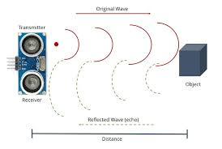
Attention

- The module is not suggested to connect directly to electric, if connected electric, the GND terminal should be connected the module first, otherwise, it will affect the normal work of the module.
- When tested objects, the range of area is not less than 0.5 square meters and the plane requests as smooth as possible, otherwise ,it will affect the results of measuring.

PIR MOTION SENSOR

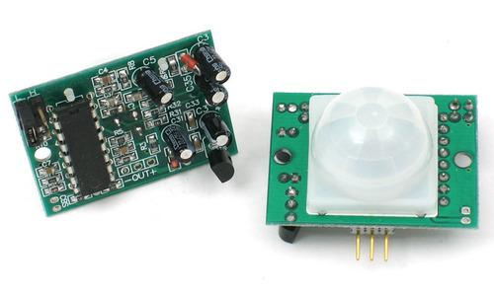
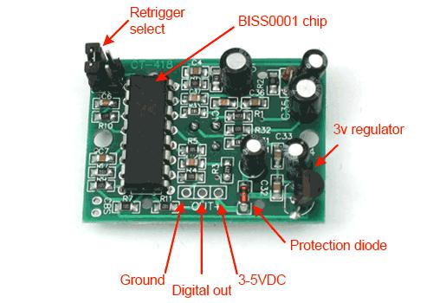

For many basic projects or products that need to detect when a person has left or entered the area, or has approached, PIR sensors are great. They are low power and low cost, pretty rugged, have a wide lens range, and are easy to interface with. Note that PIRs won't tell you how many people are around or how close they are to the sensor, the lens is often fixed to a certain sweep and distance (although it can be hacked somewhere) and they are also sometimes set off by housepets. Experimentation is key!

HOW PIRS WORK

PIR sensors are more complicated than many of the other sensors explained in these tutorials (like photocells, FSRs and tilt switches) because there are multiple variables that affect the sensors input and output. To begin explaining how a basic sensor works, we'll use this rather nice diagram

The PIR sensor itself has two slots in it, each slot is made of a special material that is sensitive to IR. The lens used here is not really doing much and so we see that the two slots can 'see' out past some distance (basically the sensitivity of the sensor). When the sensor is idle, both slots detect the same amount of IR, the ambient amount radiated from the room or walls or outdoors. When a warm body like a human or animal passes by, it first intercepts one half of the PIR sensor, which causes a positive differential change between the two halves. When the warm body leaves the sensing area, the reverse happens, whereby the sensor generates a negative differential change. These change pulses are what is detected.

THE PIR SENSOR

The IR sensor itself is housed in a hermetically sealed metal can to improve noise/temperature/humidity immunity. There is a window made of IR- transmissive material (typically coated silicon since that is very easy to come by) that protects the sensing element. Behind the window are the two balanced sensors.

LENSES

PIR sensors are rather generic and for the most part vary only in price and sensitivity. Most of the real magic happens with the optics. This is a pretty good idea for manufacturing: the PIR sensor and circuitry is fixed and costs a few dollars. The lens costs only a few cents and can change the breadth, range, sensing pattern, very easily.

In the diagram up top, the lens is just a piece of plastic, but that means that the detection area is just two rectangles. Usually we'd like to have a detection area that is much larger. To do that, we use a simple

The different faceting and sub-lenses create a range of detection areas, interleaved with each other. That's why the lens centers in the facets above are 'inconsistent' - every other one points to a different half of the PIR sensing element

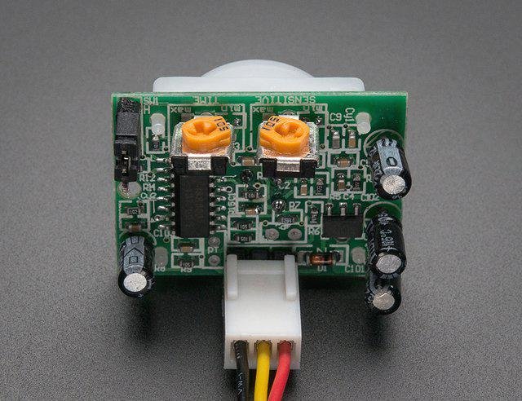

Most PIR modules have a 3-pin connection at the side or bottom. The pinout may vary between modules so triple-check the pinout! It's often silkscreened on right next to the connection (at least, ours is!) One pin will be ground, another will be signal and the final one will be power. Power is usually 3-5VDC input but may be as high as 12V. Sometimes larger modules don't have direct output and instead just operate a relay in which case there is ground, power and the two switch connections.

The output of some relays may be 'open collector' - that means it requires a pullup resistor. If you're not getting a variable output be sure to try attaching a 10K pullup between the signal and power pins.

An easy way of prototyping with PIR sensors is to connect it to a breadboard since the connection port is 0.1" spacing. Some PIRs come with header on them already, the one's from adafruit have a straight 3-pin header on them for connecting a cable

ARDUINO UNO CONTROLLER

The Arduino Uno is a microcontroller board based on the ATmega328. It has 14 digital input/output pins (of which six can be used as PWM outputs), six analog inputs, a 16 MHz crystal oscillator, a USB connection, a power jack, an ICSP header, and a reset button. It contains everything needed to support the microcontroller; simply connect it to a computer with a USB cable or power it with an AC-to-DC adapter or battery to get started. The Arduino Uno differs from all preceding boards because it does not use the FTDI USB-to-serial driver chip. Instead, it features the ATmega8U2 programmed as a USB-to-serial converter. Revision 2 of the Arduino Uno board has a resistor pulling the 8U2 HWB line to ground, making it easier to put into DFU mode.

"Uno" means one in Italian and was chosen to mark the release of Arduino Software (IDE) 1.0. The Uno board and version 1.0 of Arduino Software (IDE) were the reference versions of Arduino, now evolved to newer releases. The Uno board is the first in a series of USB Arduino boards, and the reference model for the Arduino platform; for an extensive list of current, past or outdated boards see the Arduino index of boards.

This is the Arduino Uno R3. In addition to all the features of the previous board, the Uno now uses an ATmega16U2 instead of the 8U2 found on the Uno (or the FTDI found on previous generations). This allows for faster transfer rates and more memory. No drivers needed for Linux or Mac (inf file for Windows is needed and included in the Arduino IDE), and the ability to have the Uno show up as a keyboard, mouse, joystick, etc.

The Uno R3 also adds SDA and SCL pins next to the AREF. In addition, there are two new pins placed near the RESET pin. One is the IOREF that allow the shields to adapt to the voltage provided from the board. The other is a not connected and is reserved for future purposes. The Uno R3 works with all existing shields but can adapt to new shields which use these additional pins.
The Arduino Uno is a microcontroller board based on the ATmega328. Arduino is an open-source, prototyping platform and its simplicity makes it ideal for hobbyists to use as well as professionals. The Arduino Uno has 14 digital input/output pins (of which 6 can be used as PWM outputs), 6 analog inputs, a 16 MHz crystal oscillator, a USB connection, a power jack, an ICSP header, and a reset button. It contains everything needed to support the microcontroller; simply connect it to a computer with a USB cable or power it with a AC-to-DC adapter or battery to get started.

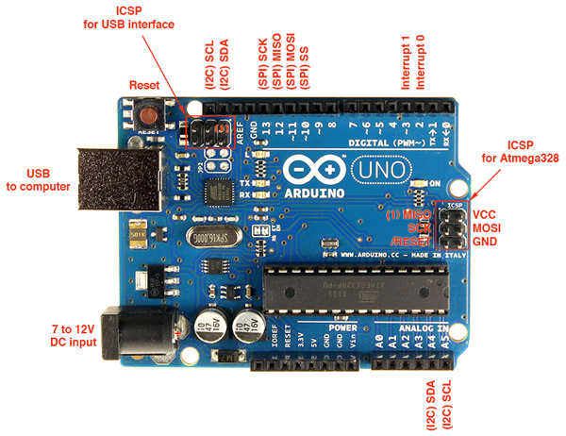
The Arduino Uno differs from all preceding boards in that it does not use the FTDI USB-to-serial driver chip. Instead, it features the Atmega8U2 microcontroller chip programmed as a USB-to-serial converter.

"Uno" means one in Italian and is named to mark the upcoming release of Arduino 1.0. The Arduino Uno and version 1.0 will be the reference versions of Arduno, moving forward. The Uno is the latest in a series of USB Arduino boards, and the reference model for the Arduino platform.

PROGRAMMING

The Arduino Uno can be programmed with the (Arduino Software (IDE)). Select "Arduino/Genuino Uno from the Tools > Board menu (according to the microcontroller on your board). For details, see the reference and tutorials. The ATmega328 on the Arduino Uno comes pre-programmed with a boot loader that allows you to upload new code to it without the use of an external hardware programmer. It communicates using the original STK500 protocol (reference, C header files). You can also bypass the boot loader and program the microcontroller through the ICSP (In‐Circuit Serial Programming) header using Arduino ISP or similar; see these instructions for details.

The ATmega16U2 (or 8U2 in the rev1 and rev2 boards) firmware source code is available in the Arduino repository. The ATmega16U2/8U2 is loaded with a DFU boot loader, which can be activated by: On Rev1 boards: connecting the solder jumper on the back of the board (near the map of• Italy) and then rising the 8U2. On Rev2 or later boards: there is a resistor that pulling the 8U2/16U2 HWB line to• ground, making it easier to put into DFU mode. You can then use Atmel's FLIP software (Windows) or the DFU programmer (Mac OS X and Linux) to load a new firmware. Or you can use the ISP header with an external programmer (overwriting the DFU boot loader)

POWER

AC-DC adapter (wall‐wart) or battery. The adapter can be connected by plugging a 2.1mm center‐positive plug into the board's power jack. Leads from a battery can be inserted in the GND and Vin pin headers of the POWER connector. The board can operate on an external supply from 6 to 20 volts. If supplied with less than 7V, however, the 5V pin may supply less than five volts and the board may become unstable. If using more than 12V, the voltage regulator may overheat and damage the board. The recommended range is 7 to 12 volts.

Vin. The input voltage to the Arduino/Genuino board when it's using an external power source (as opposed to 5 volts from the USB connection or other regulated power source). You can supply voltage through this pin, or, if supplying voltage via the power jack, access it through this pin. 5V.This pin outputs a regulated 5V from the regulator on the board. The board can be supplied with power either from the DC power jack (7 ‐ 12V), the USB connector (5V), or the VIN pin of the board (7‐12V). Supplying voltage via the 5V or 3.3V pins bypasses the regulator, and can damage your board. We don't advise it. 3V3. A 3.3 volt supply generated by the on‐board regulator. Maximum current draw is 50 mA. GND. Ground pins. IOREF. This pin on the Arduino/Genuino board provides the voltage reference with which the microcontroller operates. A properly configured shield can read the IOREF pin voltage and select the appropriate power source or enable voltage translators on the outputs to work with the 5V or 3.3V.

INPUT AND OUTPUT

Serial: 0 (RX) and 1 (TX). Used to receive (RX) and transmit (TX) TTL serial data. These pins are connected to the corresponding pins of the ATmega8U2 USB‐to‐TTL Serial chip.

External Interrupts: 2 and 3. These pins can be configured to trigger an interrupt on a low value, a rising or falling edge, or a change in value. See the attach Interrupt() function for details.

PWM: 3, 5, 6, 9, 10, and 11. Provide 8‐bit PWM output with the analogWrite() function.SPI: 10 (SS), 11 (MOSI), 12 (MISO), 13 (SCK). These pins support SPI communication using the SPI library.
LED: 13. There is a built‐in LED driven by digital pin 13. When the pin is HIGH value, the LED is on, when the pin is LOW, it's off.

TWI: A4 or SDA pin and A5 or SCL pin. Support TWI communication using the Wire library.

The Uno has 6 analog inputs, labelled A0 through A5, each of which provide 10 bits of resolution (i.e. 1024 different values). By default they measure from ground to 5 volts, though is it possible to change the upper end of their range using the AREF pin and the analog Reference() function. There are a couple of other pins on the board:

AREF. Reference voltage for the analog inputs. Used with analog Reference().
Reset. Bring this line LOW to reset the microcontroller. Typically used to add a reset button to shields which block the one on the board.

COMMUNICATION

Arduino/Genuino Uno has a number of facilities for communicating with a computer, another Arduino/Genuino board, or other microcontrollers. The ATmega328 provides UART TTL (5V) serial communication, which is available on digital pins 0 (RX) and 1 (TX). An ATmega16U2 on the board channels this serial communication over USB and appears as a virtual com port to software on the computer. The 16U2 firmware uses the standard USB COM drivers, and no external driver is needed. However, on Windows, a .inf file is required. The Arduino Software (IDE) includes a serial monitor which allows simple textual data to be sent to and from the board. The RX and TX LEDs on the board will flash when data is being transmitted via the USB‐to‐serial chip and USB connection to the computer (but not for serial communication on pins 0 and 1).

The ATmega328 also supports I2C (TWI) and SPI communication. The Arduino Software (IDE) includes a Wire library to simplify use of the I2C bus; see the documentation for details. For SPI communication, use the SPI library

AUTOMATIC (SOFTWARE) RESET

Rather than requiring a physical press of the reset button before an upload, the Arduino/Genuino Uno board is designed in a way that allows it to be reset by software running on a connected computer. One of the hardware flow control lines (DTR) of the ATmega8U2/16U2 is connected to the reset line of the ATmega328 via a 100 nano farad capacitor. When this line is asserted (taken low), the reset line drops long enough to reset the chip. The Arduino Software (IDE) uses this capability to allow you to upload code by simply pressing the upload button in the interface toolbar. This means that the boot loader can have a shorter timeout, as the lowering of DTR can be well‐coordinated with the start of the upload. This setup has other implications. When the Uno is connected to either a computer running Mac OS X or Linux, it resets each time a connection is made to it from software (via USB). For the following half‐second or so, the boot loader is running on the Uno. While it is programmed to ignore malformed data (i.e. anything besides an upload of new code), it will intercept the first few bytes of data sent to the board after a connection is opened. If a sketch running on the board receives one‐time configuration or other data when it first starts, make sure that the software with which it communicates waits a second after opening the connection and before sending this data. The Uno board contains a trace that can be cut to disable the auto‐reset. The pads on either side of the trace can be soldered together to re‐enable it. It's labelled "RESET‐EN". You may also be able to disable the auto‐reset by connecting a 110 ohm resistor from 5V to the reset line; see this forum thread for details.

SPECIFICATIONS

- Operating Voltage 5V
- Input Voltage (recommended) 7-12V
- Input Voltage (limits) 6-20V
- Digital I/O Pins 14 (of which 6 provide PWM output)
- Analog Input Pins 6
- DC Current per I/O Pin 40 mA
- DC Current for 3.3V Pin 50 mA
- Flash Memory 32 KB (ATmega328) of which 0.5 KB used by boot loader SRAM 2 KB (ATmega328)
- EEPROM 1 KB (ATmega328)
- Clock Speed 16 MHz

Flashing an LED

Light emitting diodes (LED's) are handy for checking out what the Arduino can do.. For this task, you need an LED, a 330 ohm resistor, and some short pieces of 22 or 24 g wire. The figure to the right is a sketch of an LED and its symbol used in electronic schematics

Using 22 g solid wire, connect the 5V power pin on the Arduino to the bottom red power bus on the breadboard and the Gnd pin on the Arduino to the bottom blue power buss on the breadboard. Connect the notched or flat side of the LED (the notch or flat is on the rim that surrounds the LED base; look carefully because it can be hard to find) to the Gnd bus and the other side to a free hole in main area of the breadboard Place the resistor so that one end is in the same column as the LED and the other end is in a free column. From that column, connect a wire to digital pin 2 on the Arduino board. Your setup will look something like this To test whether the LED works, temporarily disconnect the wire from pin 2 on the Arduino board and touch to the 5V power bus. The LED should light up. If not, try changing the orientation of the LED. Place the wire back in pin 2. On the LED, current runs from the anode (+) to the cathode (-) which is marked by the notch. The circuit you just wired up is represented in schematic form in the figure to the right.

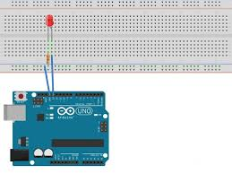

Create and run this Arduino program

void setup()
{ pinMode(2,OUTPUT);
digitalWrite(2,HIGH);
delay(1000);
digitalWrite(2,LOW);
}
void loop() {}
Did the LED light up for one second? Push the Arduino reset button to run the program again.
Now try this program, which will flash the LED at 1.0 Hz. Everything after the // on a line is a comment, as is the text between „/*‟ and „*/‟ at the top. It is always good to add comments to a program.

Blinking LED, 1.0 Hz on pin 2

void setup() // one-time actions
{
pinMode(2,OUTPUT); // define pin 2 as an output
}
void loop() // loop forever
{
digitalWrite(2,HIGH); // pin 2 high (LED on)
delay(500); // wait 500 ms
digitalWrite(2,LOW); // pin 2 low (LED off)
delay(500); // wait 500 ms
}

The pinMode command sets the LED pin to be an output. The first digitalWrite command says to set pin 2 of the Arduino to HIGH, or +5 volts. This sends current from the pin, through the resistor, through the LED (which lights it) and to ground. The delay(500) command waits for 500 msec. The second digitalWrite command sets pin 2 to LOW or 0 V stopping the current thereby turning the LED off. Code within the brackets defining the loop() function is repeated forever, which is why the LED blinks.

This exercise shows how the Arduino can control the outside world. With proper interface circuitry the same code can turn on and off motors, relays, solenoids, electromagnets, pneumatic valves or any other on-off type device.

Reading a switch

The LED exercise shows how the Arduino can control the outside world. Many applications require reading the state of sensors, including switches. The figure to the right shows a picture of a pushbutton switch and its schematic symbol. Note that the symbol represents a switch whose contacts are normally open, but then are shorted when the button is pushed. If you have a switch, use the continuity (beeper) function of a digital multimeter (DMM) to understand when the leads are open and when they are connected as the button is pushed.
For this exercise, the Arduino will read the state of a normally-open push button switch and display the results on the PC using the serial.println() command. You will need a switch, a 10 kohm resistor and some pieces of 22 g hookup wire. If you don't have a switch, substitute two wires and manually connect their free ends to simulate a switch closure. The figure below shows the schematic for the circuit on the left and a realization on the right.

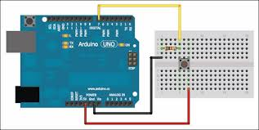

void setup()
{
Serial.begin(9600);
}
void loop()
{
Serial.println(digitalRead(3));
delay(250);
}

Open the Serial Monitor window. When the switch is open, you should see a train of 1's on the screen. When closed, the 1's change to 0's. On the hardware side, when the switch is open, no current flows through the resistor. When no current flows through a resistor, there is no voltage drop across the resistor, which means the voltage on each side is the same. In your circuit, when the switch is open, pin 3 is at 5 volts which the computer reads as a 1 state. When the switch is closed, pin 3 is directly connected to ground, which is at 0 volts. The computer reads this as a 0 state.

Now try this program which is an example of how you can have the computer sit and wait for a sensor to change state.
void setup()
{
Serial.begin(9600);
}
void loop()
{
while (digitalRead(3) == HIGH) ;
Serial.println("Somebody closed the switch!");
while (digitalRead(3) == LOW) ;
Serial.println("The switch is now open!");
}
Watch the activity in the Serial Monitor window as you press and release the switch.

Controlling a Small DC Motor

The Arduino can control a small DC motor through a transistor switch. You will need a TIP120 transistor, a 1K resistor a 9V battery with battery snap and a motor.

And here is a pictorial diagram for how to connect the components. The connections can be soldered or they can be made through a solderless breadboard.

Pin 2 can be any digital I/O pin on your Arduino. Connect the minus of the battery to the emitter of the transistor (E pin) and also connect the emitter of the transistor to Gnd on the Arduino board. To check if things are working, take a jumper wire and short the collector to the emitter pins of the transistor. The motor should turn on. Next, disconnect the 1K resistor from pin 2 and jumper it to +5V. The motor should turn on. Put the resistor back into pin 2 and run the following test program

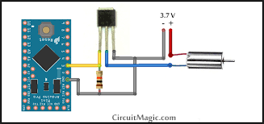

void setup()
{
pinMode(2,OUTPUT);
digitalWrite(2,HIGH);
delay(1000);
digitalWrite(2,LOW);
}
void loop()
{}
The motor should turn on for 1 second.

Arduino Hardware
The power of the Arduino is not its ability to crunch code, but rather its ability to interact with the outside world through its input-output (I/O) pins. The Arduino has 14 digital I/O pins labeled 0 to 13 that can be used to turn motors and lights on and off and read the state of switches.

Each digital pin can sink or source about 40 mA of current. This is more than adequate for interfacing to most devices, but does mean that interface circuits are needed to control devices other than simple LED's. In other words, you cannot run a motor directly using the current available from an Arduino pin, but rather must have the pin drive an interface circuit that in turn drives the motor. A later section of this document shows how to interface to a small motor.

To interact with the outside world, the program sets digital pins to a high or low value using C code instructions, which corresponds to +5 V or 0 V at the pin. The pin is connected to external interface electronics and then to the device being switched on and off.

To determine the state of switches and other sensors, the Arduino is able to read the voltage value applied to its pins as a binary number. The interface circuitry translates the sensor signal into a 0 or +5 V signal applied to the digital I/O pin. Through a program command, the Ardiomp interrogates the state of the pin. If the pin is at 0 V, the program will read it as a 0 or LOW. If it is at +5 V, the program will read it as a 1 or HIGH. If more than +5 V is applied, you may blow out your board, so be careful.

Interacting with the world has two sides. First, the designer must create electronic interface circuits that allow motors and other devices to be controlled by a low (1-10 mA) current signal that switches between 0 and 5 V, and other circuits that convert sensor readings into a switched 0 or 5 V signal. Second, the designer must write a program using the set of Arduino commands that set and read the I/O pins. Examples of both can be found in the Arduino resources section of the ME2011 web site

Programming Concepts

This chapter covers some basic concepts of computer programming, going under the assumption that the reader is a complete novice.

A computer program is a sequence of step-by-step instructions for the computer to follow. The computer will do exactly what you tell it to do, no more no less. The computer only knows what's in the program, not what you intended. Thus the origin of the phrase, "Garbage in, garbage out".

The set of valid instructions comes from the particular programming language used. There are many languages, including C, C++, Java, Ada, Lisp, Fortran, Basic, Pascal, Perl, and a thousand others. The Arduino uses a simplified variation of the C programming language.

For any programming language, the instructions must be entered in a specific syntax in order for the computer to interpret them properly. Typically, the interpretation is a two step process. A compiler takes the language specific text you enter for the program and converts it into a machine readable form that is downloaded into the processor. When the program executes, the processor executes the machine code line by line.
Basics of Programming Languages

All sequential programming languages have four categories of instructions. First are operation commands that evaluate an expression, perform arithmetic, toggle states of I/O lines, and many other operations. Second are jump commands that cause the program to jump immediately to another part of the program that is tagged with a label. Jumps are one way to break out of the normal line-by-line processing mode. For example, if you want a program to repeat over and over without stopping, have the last line of the program be a jump command that takes the program back to its first line. Third are branch commands that evaluate a condition and jump if the condition is true. For example, you might want to jump only if a number is greater than zero. Or, you might want to jump only if the state of an i/o line is low. Fourth are loop commands that repeat a section of code a specified number of times. For example, with a loop you can have a light flash on and off exactly six times.

Most programming languages contain a relatively small number of commands. The complexity of computers comes from combining and repeating the instructions several million times a second.

The commands inside the loop will be repeated six times. Following this, if the value of the variable j is greater than 4, the program will skip to the instruction tagged with the specified label, and if not, the line following the if statement will be executed.

In addition to the basic commands, languages have the ability to call functions which are independent sections of code that perform a specific task. Functions are a way of calling a section of code from a number of different places in the program and then returning from that section to the line that follows the calling line.

Digital Numbers

When working with a microcontroller that interacts with the real world, you have to dig a little below the surface to understand numbering systems and data sizes.
A binary (base 2) variable has two states, off and on, or 0 and 1, or low and high. At their core, all computers work in binary since their internal transistors can only be off or on and nothing between. Numbers are built up from many digits of binary numbers, in much the same way that in the base 10 system we create numbers greater than 9 by using multiple digits.

A bit is one binary digit that can take on values of either 0 or 1. A byte is a number comprised of 8 bits, or 8 binary digits. By convention, the bits that make up a byte are labeled right to left with bit 0 being the rightmost or least significant bit as shown below

b7 b6 b5 b4 b3 b2 b1 b0

Arduino Programming Language

The Arduino runs a simplified version of the C programming language, with some extensions for accessing the hardware. In this guide, we will cover the subset of the programming language that is most useful to the novice Arduino designer. For more information on the Arduino language, see the Language Reference section of the Arduino web site,

All Arduino instructions are one line. The board can hold a program hundreds of lines long and has space for about 1,000 two-byte variables. The Arduino executes programs at about 300,000 source code lines per sec.

Creating a Program

Programs are created in the Arduino development environment and then downloaded to the Arduino board. Code must be entered in the proper syntax which means using valid command names and a valid grammar for each code line. The compiler will catch and flag syntax errors before download. Sometimes the error message can be cryptic and you have to do a bit of hunting because the actual error occurred before what was flagged.

Although your program may pass cleanly through the syntax checker, it still might not do what you wanted it to. Here is where you have to hone your skills at code debugging. The Arduino did what you told it to do rather than what you wanted it to do. The best way to catch these errors is to read the code line by line and be the computer. Having another person go through your code also helps. Skilled debugging takes practice.

Program Formatting and Syntax

Programs are entered line by line. Code is case sensitive which means "myvariable" is different than "MyVariable". Statements are any command. Statements are terminated with a semi-colon. A classic mistake is to forget the semi-colon so if your program does not compile, examine the error text and see if you forgot to enter a colon.

Comments are any text that follows “//” on a line. For multi-line block comments, begin with “/*” and end with “*/” Constants are fixed numbers and can be entered as ordinary decimal numbers (integer only) or in hexadecimal (base 16) or in binary (base 2) as shown in the table below

Labels are used to reference locations in your program. They can be any combination of letters, numbers and underscore (_), but the first character must be a letter. When used to mark a location, follow the label with a colon. When referring to an address label in an instruction line, don't use the colon. Here's an example

repeat:

digitalWrite(2,HIGH);
delay(1000);
digitalWrite(2,LOW);
delay(1000);
goto repeat;

Use labels sparingly as they can actually make a program difficult to follow and challenging to debug. In fact, some C programmers will tell you to never use labels.

Variables are allocated by declaring them in the program. Every variable must be declared. If a variable is declared outside the braces of a function, it can be seen everywhere in the program. If it is declared inside the braces of a function, the variable can only be seen within that function.

Variables come in several flavors including byte (8-bit, unsigned, 0 to 255), word (16-bit, unsigned, 0 to 65,536), int (16-bit, signed, -32,768 to 32,767), and long (32-bit, signed, -2,147,483,648 to 2,147,483,647). Use byte variables unless you need negative numbers or numbers larger than 255, then use int variables. Using larger sizes than needed fills up precious memory space.
Symbols are used to redefine how something is named and can be handy for making the code more readable. Symbols are defined with the "#define" command and lines defining symbols should go at the beginning of your program. Here's an example without symbols for the case where an LED is connected to pin 2.

void setup()
{
pinMode(2,OUTPUT);
}
void loop()
{
digitalWrite(2,HIGH); // turn LED on
delay(1000);
digitalWrite(2,LOW); // turn LED off
delay(1000);
}
Here is the same using a symbol to define "LED"
#define LED 2 // define the LED pin
void setup()
{ pinMode(LED,OUTPUT);
}
void loop()
{
digitalWrite(LED,HIGH);
delay(500);
digitalWrite(LED,LOW);
delay(500);
}
Note how the use of symbols reduces the need for comments. Symbols are extremely useful to define for devices connected to pins because if you have to change the pin that the device connects to, you only have to change the single symbol definition rather than going through the whole program looking for references to that pin.

Program Structure

All Arduino programs have two functions, setup() and loop(). The instructions you place in the startup() function are executed once when the program begins and are used to initialize. Use it to set directions of pins or to initialize variables. The instructions placed in loop are executed repeatedly and form the main tasks of the program. Therefore every program has this structure

void setup()
{ // commands to initialize go here }
void loop()
{ // commands to run your machine go here }

LIQUID CRYSTAL DISPLAY

LCD is used to display the results of the system operation such as sensed values, motor status etc…. A liquid-crystal display (LCD) is a flat panel display, electronic visual display, or video display that uses the light modulating properties of liquid crystals. Liquid crystals do not emit light directly. The LCD standard requires 3 control lines and 8 I/O lines for the data bus. The most commonly used Character based LCDs are based on Hitachi's HD44780 controller or other which are compatible with HD44580. In this tutorial, we will discuss about character based LCDs, their interfacing with various microcontrollers, various interfaces (8-bit/4-bit), programming, special stuff and tricks you can do with these simple looking LCDs which can give a new look to your application.

PIN DESCRIPTION
The most commonly used LCDs found in the market today are 1 Line, 2 Line or 4 Line LCDs which have only 1 controller and support at most of 80 charachers, whereas LCDs supporting more than 80 characters make use of 2 HD44780controllers.

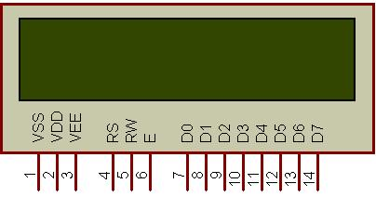
Figure 1: Character LCD type HD44780 Pin diagram

Most LCDs with 1 controller has 14 Pins and LCDs with 2 controller has 16 Pins (two pins are extra in both for back-light LED connections).

Pin description is shown in the table below.

Pin No. | Name | Description
Pin no. 1 | D7 | Data bus line 7 (MSB)
Pin no. 2 | D6 | Data bus line 6
Pin no. 3 | D5 | Data bus line 5
Pin no. 4 | D4 | Data bus line 4
Pin no. 5 | D3 | Data bus line 3
Pin no. 6 | D2 | Data bus line 2
Pin no. 7 | D1 | Data bus line 1
Pin no. 8 | D0 | Data bus line 0 (LSB)
Pin no. 9 | EN1 | Enable signal for row 0 and 1 (1stcontroller)
Pin no. 10 | R/W | 0 = Write to LCD module  1 = Read from LCD module
Pin no. 11 | RS | 0 = Instruction input  1 = Data input
Pin no. 12 | VEE | Contrast adjust
Pin no. 13 | VSS | Power supply (GND)
Pin no. 14 | VCC | Power supply (+5V)
Pin no. 15 | EN2 | Enable signal for row 2 and 3 (2ndcontroller)
Pin no. 16 | NC | Not Connected

Table 2: Character LCD pins with 2 Controller

8 data pins D7:D0
Bi-directional data/command pins.
Alphanumeric characters are sent in ASCII format.
• RS: Register Select
RS = 0 -> Command Register is selected
RS = 1 -> Data Register is selected
• R/W: Read or Write
0 -> Write, 1 -> Read
BF - Busy Flag:

Busy Flag is an status indicator flag for LCD. When we send a command or data to the LCD for processing, this flag is set (i.e BF =1) and as soon as the instruction is executed successfully this flag is cleared (BF = 0). This is helpful in producing and exact amount of delay. for the LCD processing. To read Busy Flag, the condition RS = 0 and R/W = 1 must be met and The MSB of the LCD data bus (D7) act as busy flag. When BF = 1 means LCD is busy and will not accept next command or data and BF = 0 means LCD is ready for the next command or data to process.

Instruction Register (IR) and Data Register (DR)

There are two 8-bit registers in HD44780 controller Instruction and Data register. Instruction register corresponds to the register where you send commands to LCD e.g LCD shift command, LCD clear, LCD address etc. and Data register is used for storing data which is to be displayed on LCD. when send the enable signal of the LCD is asserted, the data on the pins is latched in to the data register and data is then moved automatically to the DDRAM and hence is displayed on the LCD. Data Register is not only used for sending data to DDRAM but also for CGRAM, the address where you want to send the data, is decided by the instruction you send to LCD. We will discuss more on LCD instruction set further in this tutorial.

Commands and Instruction set

Only the instruction register (IR) and the data register (DR) of the LCD can be controlled by the MCU. Before starting the internal operation of the LCD, control information is temporarily stored into these registers to allow interfacing with various MCUs, which operate at different speeds, or various peripheral control devices. The internal operation of the LCD is determined by signals sent from the MCU. These signals, which include register selection signal (RS), read/write signal (R/W), and the data bus (DB0 to DB7), make up the LCD instructions (Table 3). There are four categories of instructions that:
- Designate LCD functions, such as display format, data length, etc.
- Set internal RAM addresses
- Perform data transfer with internal RAM

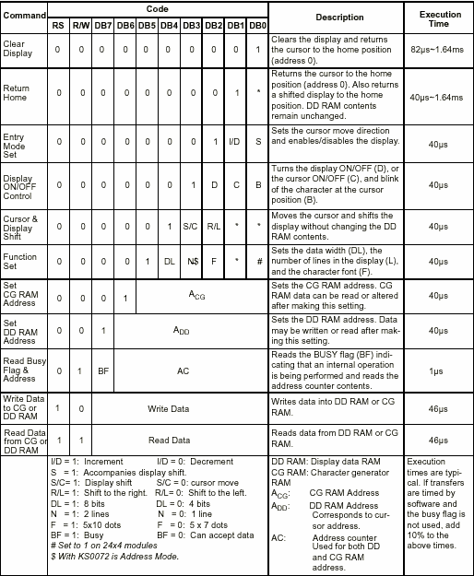

Although looking at the table you can make your own commands and test them. Below is a brief list of useful commands which are used frequently while working on the LCD.

No. | Instruction | Hex | Decimal
1 | Function Set: 8-bit, 1 Line, 5x7 Dots | 0x30 | 48
2 | Function Set: 8-bit, 2 Line, 5x7 Dots | 0x38 | 56
3 | Function Set: 4-bit, 1 Line, 5x7 Dots | 0x20 | 32
4 | Function Set: 4-bit, 2 Line, 5x7 Dots | 0x28 | 40
5 | Entry Mode | 0x06 | 6
6 | Display off Cursor off (clearing display without clearing DDRAM content) | 0x08 | 8
7 | Display on Cursor on | 0x0E | 14
8 | Display on Cursor off | 0x0C | 12
9 | Display on Cursor blinking | 0x0F | 15
10 | Shift entire display left | 0x18 | 24
12 | Shift entire display right | 0x1C | 30
13 | Move cursor left by one character | 0x10 | 16
14 | Move cursor right by one character | 0x14 | 20
15 | Clear Display (also clear DDRAM content) | 0x01 | 1
16 | Set DDRAM address or coursor position on display | 0x80+add* | 128+add*
17 | Set CGRAM address or set pointer to CGRAM location | 0x40+add** | 64+add**

Table 4: Frequently used commands and instructions for LCD

* DDRAM address given in LCD basics section see Figure 2,3,4
** CGRAM address from 0x00 to 0x3F, 0x00 to 0x07 for char1 and so on.

INTERNET OF THINGS

The Internet of things (IoT) is the network of devices such as vehicles, and home appliances that contain electronics, software, actuators, and connectivity which allows these things to connect, interact and exchange data.

The IoT involves extending Internet connectivity beyond standard devices, such as desktops, laptops, smartphones and tablets, to any range of traditionally dumb or non-internet-enabled physical devices and everyday objects. Embedded with technology, these devices can communicate and interact over the Internet, and they can be remotely monitored and controlled.

INTERNET OF THINGS (IoT)

The Internet of things (IoT) is the network of physical devices, vehicles, home appliances and other items embedded with electronics, software, sensors, actuators, and network connectivity which enable these objects to connect and exchange data. Each thing is uniquely identifiable through its embedded computing system but is able to inter-operate within the existing Internet infrastructure. Experts estimate that the IoT will consist of about 30 billion objects by 2020. It is also estimated that the global market value of IoT will reach $7.1 trillion by 2020.The IoT allows objects to be sensed or controlled remotely across existing network infrastructure, creating opportunities for more direct integration of the physical world into computer-based systems, and resulting in improved efficiency, accuracy and economic benefit in addition to reduced human intervention. When IoT is augmented with sensors and actuators, the technology becomes an instance of the more general class of cyber-physical systems, which also encompasses technologies such as smart grids, virtual power plants, smart homes, intelligent transportation and smart cities."Things", in the IoT sense, can refer to a wide variety of devices such as heart monitoring implants, biochip transponders on farm animals, cameras streaming live feeds of wild animals in coastal waters, automobiles with built-in sensors, DNA analysis devices for environmental/food/pathogen monitoring, or field operation devices that assist fire fighters in search and rescue operations. Legal scholars suggest regarding "things" as an "inextricable mixture of hardware, software, data and service".

IOT KEY FEATURES

The most important features of IoT include artificial intelligence, connectivity, sensors, active engagement, and small device use. A brief review of these features is given below

AI – IoT essentially makes virtually anything “smart”, meaning it enhances every aspect of life with the power of data collection, artificial intelligence algorithms, and networks.
This can mean something as simple as enhancing your refrigerator and cabinets to detect when milk and your favorite cereal run low, and to then place an order with your preferred grocer.

Connectivity – New enabling technologies for networking, and specifically IoT
networking, mean networks are no longer exclusively tied to major providers. Networks can exist on a much smaller and cheaper scale while still being practical. IoT creates these small networks between its system devices.

Sensors – IoT loses its distinction without sensors. They act as defining instruments which transform IoT from a standard passive network of devices into an active system capable of real-world integration.

Active Engagement – Much of today's interaction with connected technology happens through passive engagement. IoT introduces a new paradigm for active content, product, or service engagement.

Small Devices – Devices, as predicted, have become smaller, cheaper, and more
powerful over time. IoT exploits purpose-built small devices to deliver its precision, scalability, and versatility.

IOT ADVANTAGES

The advantages of IoT span across every area of lifestyle and business. Here is a list of some of the advantages that IoT has to offer:

IMPROVED CUSTOMER ENGAGEMENT – Current analytics suffer from blind-spots and significant flaws in accuracy; and as noted, engagement remains passive. IoT completely transforms this to achieve richer and more effective engagement with audiences.

TECHNOLOGY OPTIMIZATION – The same technologies and data which improve the customer experience also improve device use, and aid in more potent improvements to technology. IoT unlocks a world of critical functional and field data.

REDUCED WASTE IoT makes areas of improvement clear. Current analytics give us superficial insight, but IoT provides real-world information leading to more effective management of resources.

ENHANCED DATA COLLECTION – Modern data collection suffers from its limitations and its design for passive use. IoT breaks it out of those spaces, and places it exactly where humans really want to go to analyze our world. It allows an accurate picture of everything.

IOT – DISADVANTAGES

Though IoT delivers an impressive set of benefits, it also presents a significant set of challenges. Here is a list of some its major issues:

Security - IoT creates an ecosystem of constantly connected devices communicating over networks. The system offers little control despite any security measures. This leaves users exposed to various kinds of attackers.

Privacy – The sophistication of IoT provides substantial personal data in extreme detail without the user's active participation.

Complexity – Some find IoT systems complicated in terms of design, deployment, and maintenance given their use of multiple technologies and a large set of new enabling technologies.
Flexibility – Many are concerned about the flexibility of an IoT system to integrate easily with another. They worry about finding themselves with several conflicting or locked systems.

Compliance – IoT, like any other technology in the realm of business, must comply with regulations. Its complexity makes the issue of compliance seem incredibly challenging when many consider standard software compliance a battle.

IOT SOFTWARE

IoT software addresses its key areas of networking and action through platforms, embedded systems, partner systems, and middleware. These individual and master applications are responsible for data collection, device integration, real-time analytics, and application and process extension within the IoT network. They exploit integration with critical business systems (e.g., ordering systems, robotics, scheduling, and more) in the execution of related tasks.

Data Collection

This software manages sensing, measurements, light data filtering, light data security, and aggregation of data. It uses certain protocols to aid sensors in connecting with real-time, machine-to-machine networks. Then it collects data from multiple devices and distributes it in accordance with settings. It also works in reverse by distributing data over devices. The system eventually transmits all collected data to a central server.

Device Integration

Software supporting integration binds (dependent relationships) all system devices to create the body of the IoT system. It ensures the necessary cooperation and stable networking between devices. These applications are the defining software technology of the IoT network because without them, it is not an IoT system. They manage the various applications, protocols, and limitations of each device to allow communication.

Real-Time Analytics

These applications take data or input from various devices and convert it into viable actions or clear patterns for human analysis. They analyze information based on various settings and designs in order to perform automation-related tasks or provide the data required by industry.

Application and Process Extension

These applications extend the reach of existing systems and software to allow a wider, more effective system. They integrate predefined devices for specific purposes such as allowing certain mobile devices or engineering instruments access. It supports improved productivity and more accurate data collection.

BUZZER

A buzzer or beeper is a signalling device, usually electronic, typically used in automobiles, household appliances such as a microwave oven, or game shows.

It most commonly consists of a number of switches or sensors connected to a control unit that determines if and which button was pushed or a preset time has lapsed, and usually illuminates a light on the appropriate button or control panel, and sounds a warning in the form of a continuous or intermittent buzzing or beeping sound. Initially this device was based on an electromechanical system which was identical to an electric bell without the metal gong (which makes the ringing noise). Often these units were anchored to a wall or ceiling and used the ceiling or wall as a sounding board. Another implementation with some AC-connected devices was to implement a circuit to make the AC current into a noise loud enough to drive a loudspeaker and hook this circuit up to a cheap 8-ohm speaker. Nowadays, it is more popular to use a ceramic-based piezoelectric sounder like a Sonalert which makes a high-pitched tone. Usually these were hooked up to "driver" circuits which varied the pitch of the sound or pulsed the sound on and off.

In game shows it is also known as a "lockout system," because when one person signals ("buzzes in"), all others are locked out from signalling. Several game shows have large buzzer buttons which are identified as "plungers".

The word "buzzer" comes from the rasping noise that buzzers made when they were electromechanical devices, operated from stepped-down AC line voltage at 50 or 60 cycles. Other sounds commonly used to indicate that a button has been pressed are a ring or a beep. Some systems, such as the one used on Jeopardy!, make no noise at all, instead using light.

BUZZER MODULE
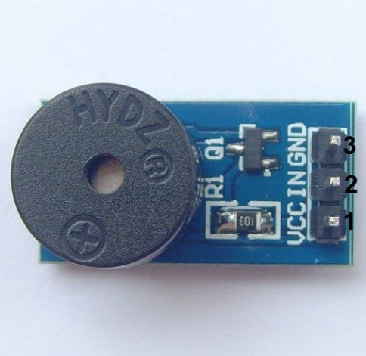

GENERAL DESCRIPTION:

A buzzer or beeper is an audio signalling device, which may be mechanical, electromechanical, or piezoelectric. Typical uses of buzzers and beepers include alarm devices, timers and confirmation of user input such as a mouse click or keystroke.
Buzzer is an integrated structure of electronic transducers, DC power supply, widely used in computers, printers, copiers, alarms, electronic toys, automotive electronic equipment, telephones, timers and other electronic products for sound devices. Active buzzer 5V Rated power can be directly connected to a continuous sound, this section dedicated sensor expansion module and the board in combination, can complete a simple circuit design, to "plug and play."

SPECIFICATIONS:
• On-board passive buzzer
• On-board 8550 triode drive
• Can control with single-chip microcontroller IO directly
• Working voltage: 5V
• Board size: 22 (mm) x12 (mm)

PIN CONFIGURATION:

1. VCC
2. Input
3. Ground

SCHEMATIC DIAGRAM:
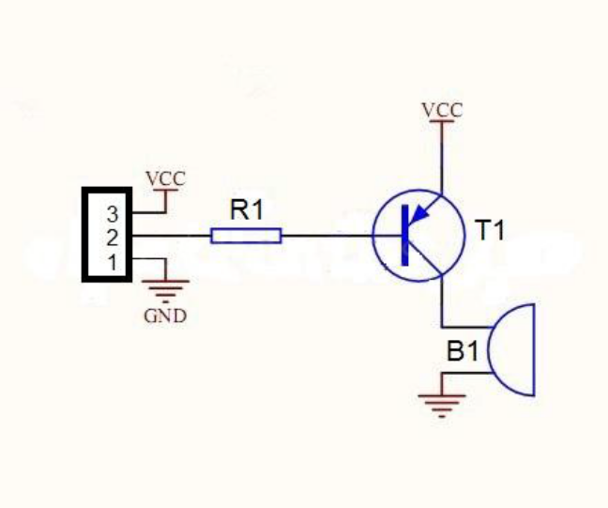

HOW TO TEST:
1. Connect your Arduino microcontroller to the computer.
2. Connect the VCC pin of your module to the to the 5V pin of your Arduino.
3. Connect the GND pin of your module to the GND pin of your Arduino.
4. Connect the Input pin of your module to the pin 13 of your Arduino.
5. Enter this program to your Arduino Integrated Development Environment (IDE):

int buzzer = 13;
void setup()
{
pinMode(buzzer, OUTPUT);
}
void loop()
{
digitalWrite(buzzer, HIGH);
delay(1000);
digitalWrite(buzzer, LOW);
delay(1000);
}
6. Lastly, click the Upload Button.

Testing Results:
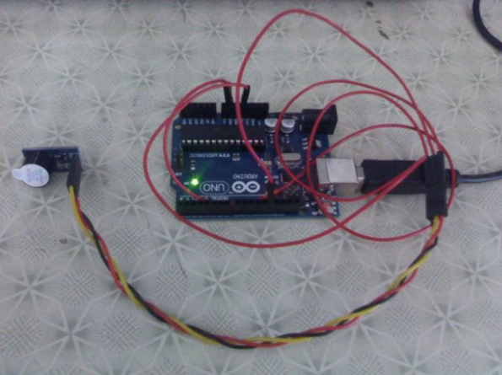

The sample sketch above is a blink which is also applicable for LEDs. The output is the turning on and off of the buzzer every other second. The picture below shows the setup of your module and Arduino:

L293D MOTOR DRIVER IC
Introduction
The L293 and L293D are quadruple high-current half-H drivers. The L293is designed to provide bidirectional drive currents of up to 1A at voltages from 4.5 V to 36 V. The L293D is designed to provide bidirectional drive currents of up to 600-mA at voltages from 4.5 V to 36 V. Both devices are designed to drive inductive loads such as relays, solenoids, dc and bipolar stepping motors, as well as other high-current/high-voltage loads in positive supply applications.
All inputs are TTL compatible. Each output is a complete totem-pole drive circuit with a Darlington transistor sink and a pseudo Darlington source. Drivers are enabled in pairs, with drivers 1 and 2 enabled by 1, 2 EN and drivers 3 and 4 enabled by 3, 4 EN. When an enable input is high, the associated drivers are enabled, and their outputs are active and in phase with their inputs. When the enable input is low, those drivers are disabled, and their outputs are off and in the high-impedance state. With the proper data inputs, each pair of drivers forms a full-H (or bridge) reversible drive suitable for solenoid or motor applications.
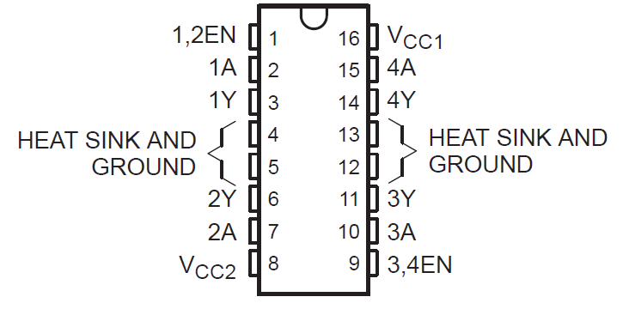Figure No. 5.1 L293D Motor Driver IC

Features of L293D Motor Driver IC
- Wide Supply-Voltage Range 4.5 V to 36 V.
- Separate Input-Logic supply.
- Internal ESD protection.
- Thermal Shutdown.
- High-Noise-Immunity Inputs.
- Functionally similar to L293
- Output current 600-mA.

DC MOTOR:

An electric motor is an electrical machine that converts electrical energy into mechanical energy. The reverse of this is the conversion of mechanical energy into electrical energy and is done by an electric generator. In normal motoring mode, most electric motors operate through the interaction between an electric motor's magnetic field and winding currents to generate force within the motor. In certain applications, such as in the transportation industry with traction motors, electric motors can operate in both motoring and generating or braking modes to also produce electrical energy from mechanical energy. Found in applications as diverse as industrial fans, blowers and pumps, machine tools, household appliances, power tools, and disk drives, electric motors can be powered by direct current (DC) sources, such as from batteries, motor vehicles or rectifiers, or by alternating current (AC) sources, such as from the power grid, inverters or generators. Small motors may be found in electric watches. General-purpose motors with highly standardized dimensions and characteristics provide convenient mechanical power for industrial use. The largest of electric motors are used for ship propulsion, pipeline compression and pumped-storage applications with ratings reaching 100 megawatts. Electric motors may be classified by electric power source type, internal construction, application, type of motion output, and so on.Electric motors are used to produce linear or rotary force (torque), and should be distinguished from devices such as magnetic solenoids and loudspeakers that convert electricity into motion but do not generate usable mechanical powers, which are respectively referred to as actuators and transducers.

MOTOR CONSTRUCTION:
ROTOR:
In an electric motor the moving part is the rotor which turns the shaft to deliver the mechanical power. The rotor usually has conductors laid into it which carry currents that interact with the magnetic field of the stator to generate the forces that turn the shaft. However, some rotors carry permanent magnets, and the stator holds the conductors.

STATOR:
The stator is the stationary part of the motor’s electromagnetic circuit and usually consists of either windings or permanent magnets. The stator core is made up of many thin metal sheets, called laminations. Laminations are used to reduce energy losses that would result if a solid core were used.
AIR GAP:
The distance between the rotor and stator is called the air gap. The air gap has important effects, and is generally as small as possible, as a large gap has a strong negative effect on the performance of an electric motor. It is the main source of the low power factor at which motors operate. The air gap increases the magnetizing current needed. For this reason air gap should be minimum. Very small gaps may pose mechanical problems in addition to noise and losses.
SALIENT-POLE ROTOR:
WINDINGS:
Windings are wires that are laid in coils, usually wrapped around a laminated soft iron magnetic core so as to form magnetic poles when energized with current. Electric machines come in two basic magnet field pole configurations: salient-pole machine and no salient-pole machine. In the salient-pole machine the pole's magnetic field is produced by a winding wound around the pole below the pole face. In the no salient-pole, or distributed field, or round-rotor, machine, the winding is distributed in pole face slots a shaded-pole motor has a winding around part of the pole that delays the phase of the magnetic field for that pole. Some motors have conductors which consist of thicker metal, such as bars or sheets of metal, usually copper, although sometimes aluminum is used. These are usually powered by electromagnetic induction.
COMMUTATOR:
A toy's small DC motor with its commutator. A commutator is a mechanism used to switch the input of most DC machines and certain AC machines consisting of slip ring segments insulated from each other and from the electric motor's shaft. The motor's armature current is supplied through the stationary brushes in contact with the revolving commutator, which causes required current reversal and applies power to the machine in an optimal manner as the rotor rotates from pole to pole.[54][55] In absence of such current reversal, the motor would brake to a stop. In light of significant advances in the past few decades due to improved technologies in electronic controller, Sensorless control, induction motor, and permanent magnet motor fields, electromechanically commutated motors are increasingly being displaced by externally commutated induction and permanent-magnet motors.
MOTOR SUPPLY AND CONTROL:
MOTOR SUPPLY:
A DC motor is usually supplied through slip ring commutator as described above. AC motors' commutation can be either slip ring commutator or externally commutated type, can be fixed-speed or variable-speed control type, and can be synchronous or asynchronous type. Universal motors can run on either AC or DC.
MOTOR CONTROL:
Fixed-speed controlled AC motors are provided with direct-on-line or soft-start starters. Variable speed controlled AC motors are provided with a range of different power inverter, variable-frequency drive or electronic commutator technologies. The term electronic commutator is usually associated with self-commutated brushless DC motor and switched reluctance motor applications.
MOTOR CONSTRUCTION:
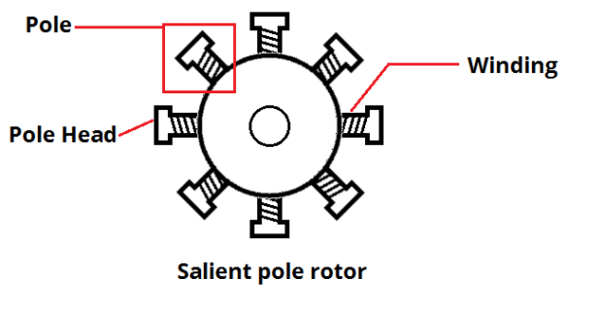
COMMUTATOR:
A commutator is a mechanism used to switch the input of most DC machines and certain AC machines consisting of slip ring segments insulated from each other and from the electric motor's shaft. The motor's armature current is supplied through the stationary brushes in contact with the revolving commutator, which causes required current reversal and applies power to the machine in an optimal manner as the rotor rotates from pole to pole.In absence of such current reversal, the motor would brake to a stop. In light of significant advances in the past few decades due to improved technologies in electronic controller, sensor less control, induction motor, and permanent magnet motor
fields, electromechanically commutated motors are increasingly being displaced
by externally commutated induction and permanent-magnet motors.
TYPE OF MOTOR COMMUTATION
MAJOR CATEGORIES  BY  SELF-COMMUTATED |  |  | EXTERNALLY COMMUTATED
MECHANICAL-  COMMUTATOR MOTORS |  | ELECTRONIC-  COMMUTATOR (EC)  MOTORS | ASYNCHRONOUS  MACHINES | SYNCHRONOUS  MACHINES
AC | DC | AC | AC
* Universal motor  (AC commutator  series motor or  AC/DC motor)  * Repulsion motor | Electrically  excited DC motor:  * Separately  excited  * Series  * Shunt  * Compound  PM DC motor | With PM rotor:  * BLDC motor  With  ferromagnetic  rotor:  * SRM | Three-phase motors:  * SCIM  * WRIM  AC motors:  * Capacitor  * Resistance  * Split  * Shaded-pole | Three-phase motors:  * WRSM  * PMSM or  BLAC motor  - IPMSM  - SPMSM  * Hybrid  AC motors:  * Permanent-split  capacitor  * Hysteresis  * Stepper  * SyRM  * SyRM-PM hybrid
Simple electronics | Rectifier,  linear transistor(s)  or DC chopper | More elaborate  electronics | Most elaborate  electronics (VFD), when provided

CONCLUSION AND FUTURE WORK

In this report, we have introduced our primitive idea to make a rescue robot using some types of primitive sensors like PIR, Ultrasonic and Temperature sensor along with robot mechanism
In future we plane enable simple Wi-Fi camera. This vehicle may be improved by using high range sensors (Laser, ultrasound or powerful thermal cameras), GPS, and motors of high capacity. Long distance telecommunication protocols will be also proposed in any future version of this robot. Our final goal is to develop a full autonomous rescue robot.

REFERENCE

[1] Detecting Direction of Movement Using Pyroelectric Infrared Sensors by Jaeseok Yun, Member, IEEE, and Min-Hwan Song.

[2] Target Detection and Classification Using Seismic and PIR Sensors-Xin Jin, Student Member, IEEE, Soumalya Sarkar, Asok Ray, Fellow, IEEE, Shalabh Gupta.

[3] Human infrared signal recognition using single PIR detector-Linhong Wang Chongqing College of Electrical Engineering Chongqing, China.

[4] Infrared Sensors Microcontroller Interface System for Mobile Robots-Matijevics, Polytech Eng. Coll. of Subotica.

[5] Sensor based obstacle avoidance and mapping for fast mobile robots-Gourley, C. Dept. of Electr. &Comput. Eng., Tennessee Univ., Knoxville, TN, USA

[6] Obstacle Avoiding Robot – A Promising One-Rakesh Chandra Kumar , Md. Saddam Khan , Dinesh Kumar ,Rajesh Birua

